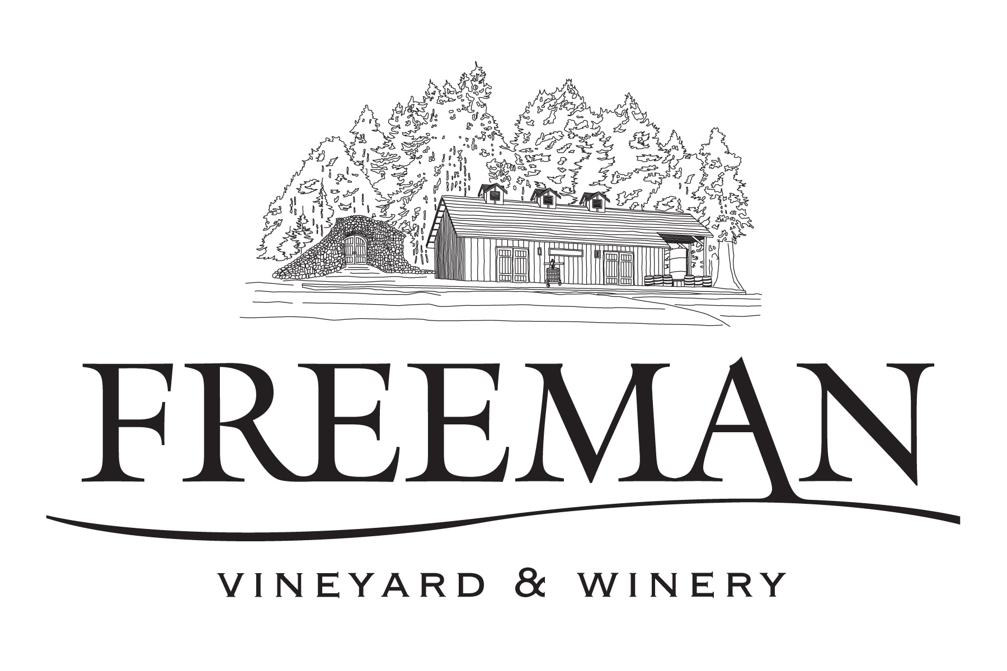

MEDIA CONTACT: Amelia S. Weir
amelia@freemanwinery.com
(415) 244-1240
www.freemanwinery.com
Facebook: Freeman Winery

FOR IMMEDIATE RELEASE

FREEMAN VINEYARD & WINERY LAUNCHES MAGNUM SALE TO RAISE $25,000 FOR THE JAPANESE EARTHQUAKE AND TSUANAMI RELIEF FUND

Sebastopol, CA, March 24, 2011 — Freeman Vineyard & Winery’s proprietors, Ken and Akiko Freeman launched a special sale of their Pinot Noir wines in magnum format with 100% of the proceeds going directly to the Japan Society of Northern California Earthquake & Tsunami Relief Fund in coordination with Give2Asia, an efficient philanthropy focused on Asia that is working for short-term and long-term recovery projects in the affected communities in Japan in partnership with Japanese relief organizations on the ground.

The sale includes all four of their wines in magnum format which are normally reserved for special events and charity. Below is the suggested donation for the wines which will include current and some library vintages. The donation excludes shipping costs:

Russian River Valley Pinot Noir $125
Sonoma Coast Pinot Noir $125
Keefer Ranch, Russian River Valley Pinot Noir $150
Akiko’s Cuvee, Sonoma Coast Pinot Noir $150

Akiko Freeman states “this natural disaster has struck a personal chord, Japan is my home and we want to be able to help in some capacity”. Freeman adds “we wanted to find a significant way to raise funds for this tragedy and help to rebuild what was lost while also paying respects to those who lost loved ones”. This one time only sale of the magnums is expected to raise $25,000.

About Freeman Vineyard & Winery:
Founded by Ken and Akiko Freeman, Freeman Vineyard & Winery is dedicated to crafting elegant cool-climate California Pinot Noir and Chardonnay in a sophisticated Burgundian style. Believing in the vast potential of the Sonoma Coast and Russian River Valley appellations to produce wines of complexity and refinement, the Freemans work with a small portfolio of acclaimed partner vineyards including Keefer and Heintz ranches. In addition, the Freemans have a seven acres estate vineyard at their picturesque winery in Sebastopol and fourteen acres at their Occidental vineyard, Freeman Ranch – both are planted with Pinot Noir. These sites share many common elements that define excellence in cool-climate viticulture, including hillside locations with coastal fog, Goldridge soils, proper clonal selection and stressed vines producing extremely low yields of nuanced fruit.

NOTE TO EDITORS: For more information or to purchase these wines, please go to http://www.freemanwinery.com/. For images, logo or more information please contact Amelia Weir, SW/PR at (415) 381-8201 or ameliasw@freemanwinery.com.

